The Henry Gray Anatomical Society Constitution
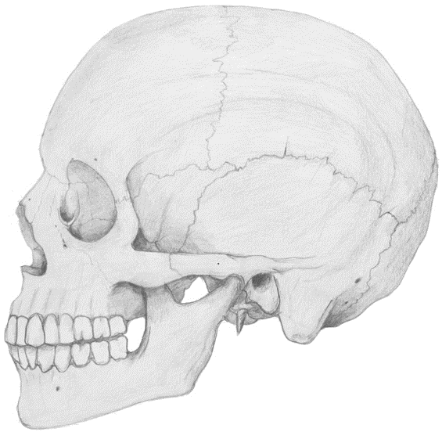
Contents

- Name
- Aims and Objectives
- Membership
- Subscriptions and Finance
- Club/Society Officials
- Duties of Club/Society Officials
- Meetings
- Voting
- Constitutional Changes
- Complaints Procedure
- SGSU Commitments
- Discipline
- Declaration

- Name

  - The Club/Society's name shall be the Henry Gray Anatomical Society. Informally, it will be known as the Anatomy Society.

2.0 Aims and Objectives

  - The mandate of the Society shall be to
- Provide an accessible avenue for all students into anatomy through society-led education initiatives
- Serve as a platform for Anatomical events held at St George’s, University of London
- Further and enrich student’s knowledge and experience in the anatomical sciences, in conjunction with the Anatomy Faculty at St George’s, University of London

  - The aim shall be achieved by
- Anatomy Clinics – Dissecting Room Teaching
- Revision Lecture Series – Student-led Lectures
- Companion Notes in Anatomy – Student-written and Peer-reviewed Publications
- Supplementary and Collaborative Events

- Membership

  - Membership of the Society will be open to all members of SGSU in accordance with SGSU Constitution and Policy.

  - Members of the Society shall act in accordance with SGSU Constitution and Policy.

4.0 Subscriptions and Finance

4.1 A membership fee is required from all Society members. The Society Officials shall determine this fee and are responsible for its collection.

  - The Society’s financial matters shall be dealt with in accordance with SGSU Constitution and Policy.

- Club/Society Officials

  - An elected committee will conduct the running of the Society.

  - The committee shall ensure that the Society abides by this Constitution.

  - The committee will consist of the following officers who shall
be members of SGSU:

- President
- Vice President
- Treasurer
- General Secretary
- Four (4) General Committee Members

  - The committee will serve for one academic year.

- Duties of Club/Society Officials

  - The President is responsible for
- The overall planning and execution for all society events
- The delegation of tasks to the rest of the committee and ensuring tasks and fulfilled to standard and in a timely manner
- Serving as the main point of contact for the SGSU and Anatomy Faculty
- Coordination of Society Membership

  - The Society Vice-President is responsible for:
- Supporting and helping the President
- Liaising with Anatomy Faculty at St George’s, University of London
- Coordination of Society Membership
- Communications with membership through email and social media

  - The Society Treasurer is responsible for:
- Planning of any expenses throughout the year
- Recording and managing incoming and outgoing cash-flow

  - The Society General Secretary is responsible for:
- Arranging meetings within the Society
- Coordinating Room-bookings with the SGSU
- Generating the minutes of meetings and ensuring they are circulated to members after the meeting
- Publicity of Society events
- Working with the General Committee on planning and execution of new society initiatives

  - The Society General Committee is responsible for:
- Running of regular Anatomy Clinics and preparation of material of high quality and a timely manner
- Leading, planning and execution of new society initiatives with the rest of the committee

7.0 Meetings

7.1 The Society Committee shall meet regularly during term time.

7.2 Regular Committee meetings are required to discuss all Society matters. Minutes shall be made available to SGSU for ratification.

8.0 Voting

8.1 This will take place for the election of Officials and any other issue that the Society deems of importance.

  - Only Society Officials will be entitled to vote.

  - The results of any election shall be passed to the Sports/Societies Officer and the General Secretary of SGSU at the earliest opportunity.

9.0 Changes to the Club/Society Constitution

  - Changes can be implemented if a two-thirds majority is obtained at an annual or extraordinary general meeting of the Society Committee.

  - Any changes shall be deemed provisional until passed to the Sports/Societies Officer and the General Secretary of SGSU at the earliest opportunity and subsequently ratified.

- Clubs/Societies Complaints Procedure

  - Any complaints shall be dealt with in accordance with SGSU Constitution and Policy.

- SGSU Commitments

  - The Society shall adhere to SGSU Constitution and Policy
.

- Discipline

  - Any disciplinary matters shall be dealt with in accordance with SGSU Constitution and Policy.

- Declaration

I declare that the Henry Gray Anatomical Society shall abide by this

Constitution, drawn up on this …th day of the …th month, 20..

__________________________ Henry Gray Anatomical Society President
Sign, Print and Date

I declare that this Constitution has been ratified by SGSU and the
Henry Gray Anatomical Society is hereby recognized by SGSU

__________________________ SGSU Sports/Societies Officer
Sign, Print and Date

__________________________ SGSU General Secretary
Sign, Print and Date

