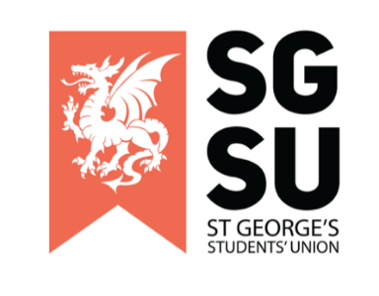
Union Progress Meeting
20th September 2022

6:00pm – 8:00pm, Michael Heron Lecture Theatre

- Apologies for Absence (Rishi)

- Review of minutes of meeting on 23rd August 2022 (Rishi)

- Proposal for Post Grad Reps (Ayesha)

To Receive and consider:
- Paper A

- New society proposals

To receive and consider:
- Ice skating society (Zhenya Nerukh)
- Squash Society (Benjamin Smeaton)

- Societies update (Ogor)

To receive and consider:
- Fresher’s Events
- Rob Lowe

- Any Other Business

