Learning Microbiology through Clinical Consultation; A new textbook for medical students
Actually the medical students at St Georges Hospital had a key role in the publication of Learning Microbiology through Clinical Consultation and this is a great opportunity to say thank you.
Of course the students that responded to my email must now be qualified doctors; the youngest was in year 2 and the oldest was just qualified, so they could be anything from foundation to registrar level. I wonder what specialties they are in now?
At this time in 2011 I was writing a book proposal to Oxford University Press (OUP). I had written 5 sample chapters and I sent them to the group of students that had expressed interest in being involved, asking for their opinion in a structured questionnaire.
Here is what they wrote back;
I liked the case studies because of the 1st person. The very descriptive prose at the beginning of each one made me feel as if I was that doctor. That makes the book more exciting and inviting as I am currently spending all my time in the library and hardly see patients.

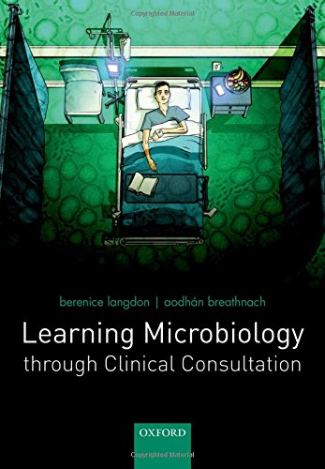
Getting the clinician to admit that they are not sure, and think about the differential diagnosis was really nice. We are training for a practical job, and this format relates to that and makes it seem really exciting.

It is quite a unique take on presenting a history which creates an atmosphere as well which I think helps the reader to feel like they are observing a consultation with all its subtleties instead of just the facts. Also this hopefully will make the learning points more memorable if you can attach it to the story.

Refreshing to read. It reads like a story to get across the points. It definitely gives this book a unique appeal. I can remember the cases and their details quite well as I am someone who has a good memory for people/characters rather than details just on their own.

It is easy to imagine oneself sitting in the doctor’s seat, conducting the consultation. I read the case story a paragraph at a time, thinking about how I would have asked the questions.

What I particularly liked about the theory section of this book was that it was understandable to students at all stages of their medical training, it was concise, and relevant to clinical practice.
I was very happy to have such nice things said about my writing and I was able to include these comments in my book proposal to OUP who eventually offered me a contract! So you can see what a big difference that careful and thoughtful feedback made.
As you can see from the title page it was not just me that wrote the chapters but a consultant from your Hospital; Dr Breathnach , one of St Georges Hospitals microbiologists and head of the labs here. I had had some interaction with him because he had helped me with an antibiotics audit I had done at my practice. So I telephoned him and asked him to be a co-author on the project and he said ‘yes.’ Just like that! Without asking any questions at all! Of course then I explained a bit more so that he could change his mind if he wished, but he still said he would like to and I have really enjoyed working with him. Dr Breathnach’s descriptions and explanations are very clear, perhaps because he is already used to explaining things to medical students, he wrote down what he would normally explain to you in a lecture.
So all in all, St Georges Hospital and Medical School has had a big influence on this project. It has allowed me the opportunity to write and complete this book and I would like to say THANKYOU!
Yours Berenice
Dr B Langdon
MBBS BSc MRCGP
If you would like to know more please look up;
https://www.amazon.co.uk/Learning-Microbiology-through-Clinical-Consultation/dp/0198719841/ref=sr_1_1?ie=UTF8&qid=1467994795&sr=8-1&keywords=breathnach+langdon
This site includes a ‘look inside’ option allowing access to the first few cases.

