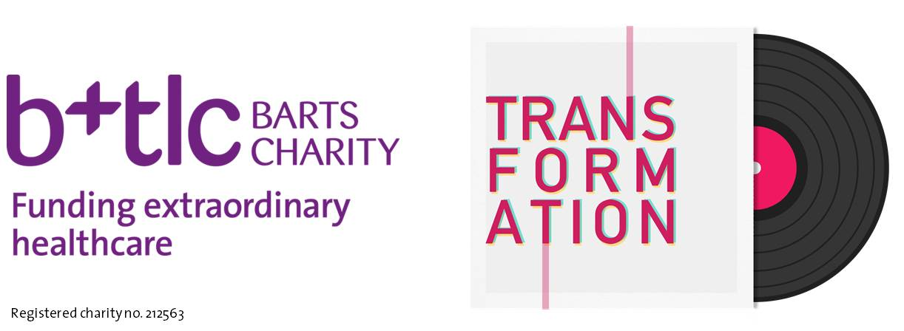

More people under the age of 40 are killed by traumatic injuries each year than any disease in the world. Whether it is road traffic accidents, violent crime, falls or suicide, trauma has a devastating effect on young people, their families and their friends. Through research based improvements in the understanding of trauma care, the death rate from serious injury in London has HALVED. But trauma research, care and recovery is still massively underfunded and misunderstood.

Until now...

On Saturday 19 November 2016 Barts Charity is hosting the first UK concert dedicated to raising the awareness of trauma and vital funds for the Trauma Centre at the Royal London Hospital, Whitechapel, the busiest trauma centre in Europe.

Featuring No.1 singer/songwriter Becky Hill, double MOBO nominee Kojey Radical, indie stars Beach Baby and 1Xtra's tip for 2016 Rukshana Merrise, it will be a unique and very special night of music, held at Village Underground, Shoreditch.

We would like to offer St George’s students the chance to win 2 pairs of tickets.

Entering is simple:

Retweet the pinned tweet at the top of Barts Charity’s profile at twitter.com/Barts_Charity and answer the following question -

Q: Globally, which is the biggest cause of death for people under the age of 40?
A. Malaria
B. Trauma
C. TB
D. Cancer

Email your answer and your name to Appeals@bartshealth.nhs.uk by 5pm on Friday 21 October 2016.

Good luck

T&C's:
1. The winners will be selected at random from all valid entrants received by the Closing Date of Friday 21 October at 5pm.
2. Entrants must be students at St George’s, full, part time or distance.
3. Entrance to the Transformation concert is strictly over 18s.
4. Barts Charity will not pass on details to any third parties and does not participate in any telephone marketing.
5. Barts Charity is a registered charity, Registration No. 212563 and a member of the Fundraising Standards Board.
6. Tickets and more information about the event can be found at www.bartscharity.org.uk/transformation
7. No correspondence will be entered into in respect of this competition except with the prize winners 8. These terms and conditions are governed by the laws of England and Wales. Any disputes arising under or in connection with them shall be subject to the exclusive jurisdiction of the courts of England.
9. Entry into the competition is dependent on your acceptance of these terms and conditions and by entering the competition you confirm your acceptance of these terms and conditions

