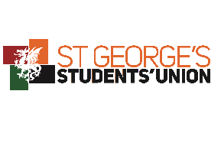
Food Safety Advice – Bake Sales
When you're making food for large numbers of people, it's important to make sure that food is handled, prepared and stored safely. Here are some general practical tips:
- Wash your hands and any equipment you are using in hot soapy water;
- Keep food out of the fridge for the shortest time possible;
- Always make sure food is properly cooked before you serve it;
- Do not use ingredients past their ‘use by’ date;
- Know what is in the ingredients so information about allergens can be provided (e.g. provide a ’contains nuts’ label for cakes);
On the day, people bringing in cakes from home or running the stall should follow these tips:
- Transport cakes in a clean, sealable container;
- Make sure that cheesecake and any cakes or desserts containing cream are left out of the fridge for the shortest time possible;
- Wear disposable gloves to serve food;
- When handling cakes use tongs or a cake slice instead or hands;
In general the labelling regulations won't apply to most food being sold for charity and so won't need to be labelled. However, even if you're not legally required to label a food, it is good practice to do so. Labels could include:
- The product name
- A list of ingredients (in descending order of weight)
- Details of any ingredients that could cause an allergic reaction – such as egg, milk, sulphites, peanuts and tree nuts
If you do label food, you must make sure that the information you provide is clear and accurate.

