Volleyball Club Constitution

Contents

- Name
- Aims and Objectives
- Membership
- Subscriptions and Finance
- Club/Society Officials
- Duties of Club/Society Officials
- Meetings
- Voting
- Constitutional Changes
- Complaints Procedure
- SGSU Commitments
- Discipline
- Declaration

- Name

  - The Club/Society's name shall be ‘Volleyball Club’

2.0 Aims and Objectives

  - The aim of the Club/Society shall be to establish a volleyball club and team able to participate in matches against other universities.
  - The aim shall be achieved by meeting weekly to train and polish skills as well as recruiting more members for the team.

- Membership

  - Membership of the Club/Society will be open to all members of SGSU in accordance with SGSU Constitution and Policy.

  - Members of the Club/Society shall act in accordance with SGSU Constitution and Policy.

4.0 Subscriptions and Finance

4.1 A membership fee is required from all Club/Society members. The Club/Society Officials shall determine this fee and are responsible for its collection.

  - The Club’s/Society’s financial matters shall be dealt with in accordance with SGSU Constitution and Policy.

- Club/Society Officials

  - An elected committee will conduct the running of the Club/Society.

  - The committee shall ensure that the Club/Society abides by this Constitution.

  - The committee will consist of the following officers who shall
be members of SGSU:

- President/Captain
- Treasurer
- Secretary
- Social Secretary

  - The committee will serve for one academic year.

- Duties of Club/Society Officials

  - The Club/Society President/Captain is responsible for:
- Organising the weekly sessions.
- Deciding weekly goals of the club

  - The Club/Society Vice-President is responsible for:
- Aiding the president in their duties.
- Taking over duties when the president is unable to do so.

  - The Club/Society Treasurer is responsible for:
- Collecting subs from members.
- Arranging for sponsors/donations.
- Keeping track of club expenditure.

  - The Club/Society Secretary is responsible for:
- Completing all paperwork necessary.
- Ensuring that the university receives the paperwork.

  - The Club/Society Social Secretary is responsible for:
- Organising social events for the members to attend
- Advertising the club to prospective members during fresher’s week.

7.0 Meetings

7.1 The Club/Society Committee shall meet regularly during term time.

7.2 Regular Committee meetings are required to discuss all Club/Society matters. Minutes shall be made available to SGSU for ratification.

8.0 Voting

8.1 This will take place for the election of Officials and any other issue that the Club/Society deems of importance.

  - Only Club/Society members will be entitled to vote.

  - The results of any election shall be passed to the Sports/Societies Officer and the General Secretary of SGSU at the earliest opportunity.

9.0 Changes to the Club/Society Constitution

  - Changes can be implemented if a two-thirds majority is obtained at an annual or extraordinary general meeting of the Club/Society.

  - Any changes shall be deemed provisional until passed to the Sports/Societies Officer and the General Secretary of SGSU at the earliest opportunity and subsequently ratified.

- Clubs/Societies Complaints Procedure

  - Any complaints shall be dealt with in accordance with SGSU Constitution and Policy.

- SGSU Commitments

  - The Club/Society shall adhere to SGSU Constitution and Policy
.

- Discipline

  - Any disciplinary matters shall be dealt with in accordance with SGSU Constitution and Policy.

- Declaration

I declare that the Volleyball Club/Society shall abide by this

Constitution, drawn up on this 20th day of the 1st month, 2016
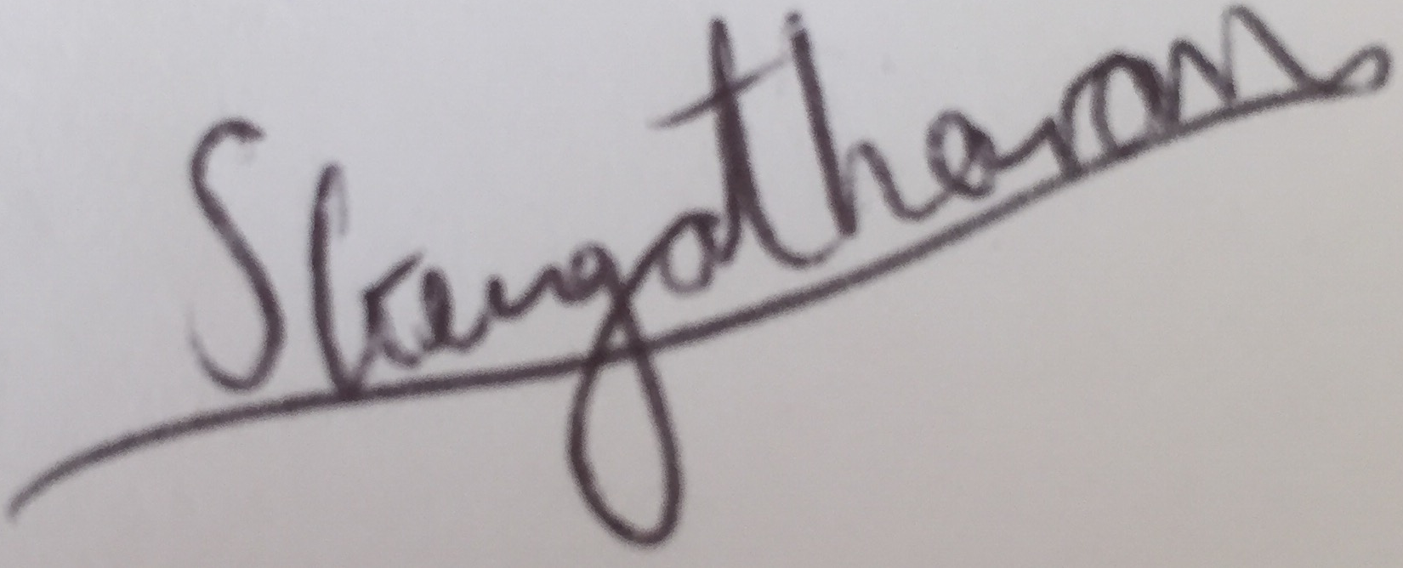

Sahana Gengatharan Date: 24/08/2016 Club/Society President
Sign, Print and Date

I declare that this Constitution has been ratified by SGSU and the

Volleyball Club/Society is hereby recognized by SGSU

______________________________ SGSU Sports/Societies Officer
Sign, Print and Date

____________________________________ SGSU General Secretary

