Constitution Template:
Aids Orphan Club/ Society Constitution
Contents
1 Name
2 Aims and Objectives
3 Membership
4 Subscriptions and Finance
5 Club/Society Officials
6 Duties of Club/Society Officials
7 Meetings
8 Voting
9 Constitutional Changes
10 Complaints Procedure
11 SGSU Commitments
12 Discipline
13 Declaration

1.0 Name
1.01 The Club/Society's name shall be AIDS Orphan
2.0 Aims and Objectives
2.01 The aim of the Club/Society shall be Fundraising and HIV Awareness
2.02 The aim shall be achieved by student led events & fundraising

3.0 Membership
3.01 Membership of the Club/Society will be open to all members of SGSU in accordance with SGSU Constitution and Policy.
3.02 Members of the Club/Society shall act in accordance with SGSU Constitution and Policy.

4.0 Subscriptions and Finance
4.0 A membership fee is required from all Club/Society members. The Club/Society Officials shall determine this fee and are responsible for its collection.
Subs have been set as £1.00
1.2 The Club's/Society's financial matters shall be dealt with in accordance with SGSU Constitution and Policy.

5.0 Club/Society Officials
5.01 An elected committee will conduct the running of the Club/Society.
5.02 The committee shall ensure that the Club/Society abides by this Constitution.
5.03 The committee will consist of the following officers who shall be members of SGSU:
President: Mohammed Athif Khan
Treasurer: Alex Beatty
Secretary: Gabriela Barzyk

5.04 The committee will serve for one academic year.
6.0 Duties of Club/Society Officials
6.01 The Club/Society President/Captain is responsible for:
-Co-ordination of student-led fundraises at SGUL e.g. Bake Sales
-Liaising with the SU + charities officers to ensure smooth running of events
-Communicating directly with the AIDS Orphan charity to keep them updated with our progress

6.02 The Club/Society Vice-President is responsible for:
N/A we don’t have a VP yet
1.3 The Club/Society Treasurer is responsible for:
This: Collecting Money on the day of fundraisers
This: Keeping balanced accounts of all the money that we receive/ spend
And This: Ensuring all members pay their subs to become official AIDS Orphan members

1.4 The Club/Society Secretary is responsible for:
This: Disseminating information via e-mail to all members of the society
This: Taking notes and minutes during meetings
And this: Answering queries about the society that the students may have

1.5 The Club/Society Aids Orphan is responsible for: Ensuring the official fundraising for the Aids Orphan charity and promoting HIV awareness
7.0 Meetings
7.1 The Club/Society Committee shall meet regularly during tem time.
7.2 Regular Committee meetings are required to discuss all Club/Society matters. Minutes shall be made available to SGSU for ratification.
8.0 Voting
8.1 This will take place for the election of Officials and any other issue that the Club/Society deems of importance.
1.2 Only Club/Society members will be entitled to vote.
1.3 The results of any election shall be passed to the Sports/Societies Officer and the General Secretary of SGSU at the earliest opportunity.
9.0 Changes to the Club/Society Constitution
1.1 Changes can be implemented if a two-thirds majority is obtained at an annual or extraordinary general meeting of the Club/Society.
1.2 Any changes shall be deemed provisional until passed to the
Sports/Societies Officer and the General Secretary of SGSU at the earliest opportunity and subsequently ratified.
10.0 Clubs/Societies Complaints Procedure
10.01 Any complaints shall be dealt with in accordance with SGSU Constitution and Policy.
11.0 SGSU Commitments
11.01 The Club/Society shall adhere to SGSU Constitution and Policy
12.0 Discipline
12.01 Any disciplinary matters shall be dealt with in accordance with SGSU Constitution and Policy.
13.0 Declaration
I declare that the Aids Orphan Club/Society shall abide by this
Constitution, drawn up on this 11th day of the 3rd month, 2016
/ Club/Society President
Sign, Print and Date
I declare that this Constitution has been ratified by SGSU and the
Club/Society is hereby recognized by SGSU
SGSU Sports/Societies Officer
SiYi, Print and Date
SGSU General Secretary

ST. GEORGES

STUDENTS' UNION
CLUB/SOCIETY
REGISTRATION AND
HANDOVER PACK 2014/2015
CLUB/SOCIETY NAME:
Committee 2015/16 Declaration
We, the committee 2015/16, declare that:
- All new committee members have been voted in democratically according to our constitution.
- All members of the society were given the opportunity to vote.
President 14/15:
Print
Treasurer 14/15:
Print Name
REQUIRED COMMITTEE MEMBERS
PRESIDENT (or Equivalent)
TREASURER

The personal details contained in this pack are covered by the Data Protection Act and thus will not be given out to anyone who asks. In order for new members to contact you, it is imperative that you provide the contact details of a committee member from your society who will deal with all enquiries.
Main Contact Details- Please write clearly
NAME: Mohammed Athif Khan
TELEPHONE No: 077/18609756
EMAIL: m1500901@sgul.ac.uk
MAIN SOCIETY EMAIL: -

FINANCE
Number of members: 1
Membership fee charged: £1

Committee 2015/16 Agreement
- We, as in the committee, agree to abide by the conditions set within and ensure that:
- We will communicate with the union on a regular basis about all events and issues affecting us.
- We will abide by our constitution and update it when necessary
- We will not agree to sponsorship deals without permission from SGSU.
- All membership fees and event takings are handed in within 24 hours or as near to as possible to the Vice President: Finance & Student Activities, and no monies are kept in petty cash.
- We will ensure that at least one representative shall attend all SGSU council meetings as required.
- Members, inclusive of the Committee shall adhere to the SGSU Constitution,
Regulations and its policies, in particular the Regulation for Clubs and Societies.
- We will abide by all SGUL policies in particular equal opportunities and child protection policies.
- We will not invalidate the Student Union's or SGUL's insurance Policies
- We will ensure next years equivalent of this form is completed in a timely manner
President 15/16:
Print d/,uuDate-UJÆ../LA

Treasurer 15/16:
Print Name: Alexandra Signed
Treasurer 2015/16 Agreement l, the society treasurer, understand that monies will only be reimbursed for purchases made with prior permission from the Vice-President Finance & Student Activities. I can however authorise purchases using money raised from subscription fees, sponsorship or donations in any way the committee sees fit. I understand all that is required to abide by the financial rules and regulations and that if I am unsure at anytime I will seek advice. I am responsible for all the financial matters for the period MAY 2016 until July 2017 (estimate if necessary). All membership fees and other money raised will be paid in and no petty cash will be withheld.
Club/Society Treasurer 2015/16
* Print Name

Please provide all details requested
If more than one person is elected to position put everyone's details down
Essential positions

President (or Equivalent)
Name: Mohammed Athif Khan
Course & Year of Study: MBBS5, Y1
D.O.B: 17/12/1996

Mobile: 07718609756
Email Address: (please write clearly): m1500901@sgul.ac.uk

Treasurer
Name: Alexandra Beatty
Course & Year of Study: BMS, Yr1
D.O.B: 07/05/97
Mobile: 07769213358
Email Address: (Please write clearly): m1506208@sgul.ac.uk

Other Positions Position:
Name:
Course & Year of Study:
D.O.B:
Mobile:
Email Address: (Please write clearly)
Position:
Name:
Course & Year of Study: D.O.B:
Mobile:
Email Address: (Please write clearly)
Position:
Name:
Course & Year of Study: D.O.B:
Mobile:
Email Address: (Please write clearly)
Position:
Name:
Course & Year of Study: D.O.B:
Mobile:
Email Address: (Please write clearly)
Position:
Name:
Course & Year of Study: D.O.B:
Mobile:
Email Address: (Please write clearly)
Position:
Name:
Course & Year of Study: D.O.B:
Mobile:
Email Address: (Please write clearly)
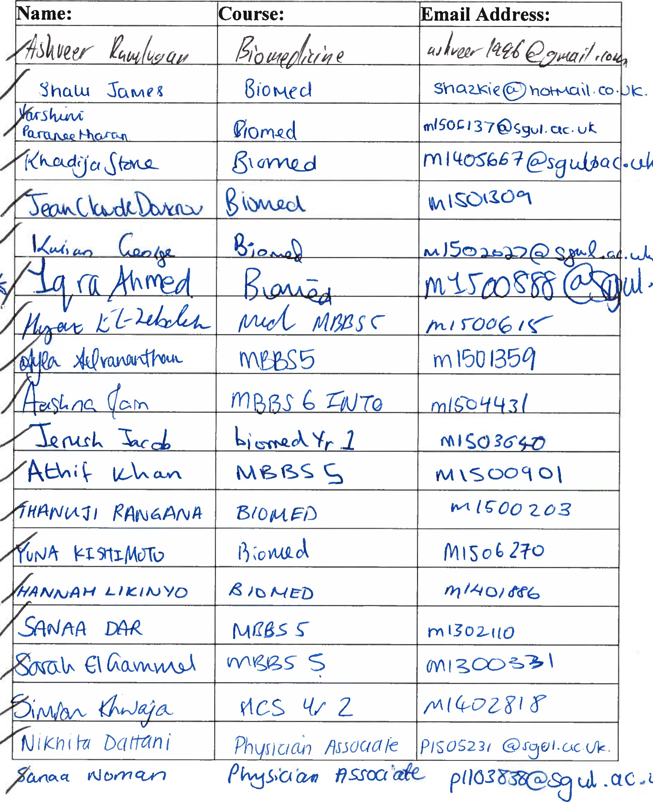
Document of Interest Template:
a
c.J
c
