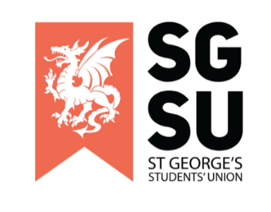
Union Progress Meeting
18th October 2022

6:00pm – 8:00pm, Michael Heron Lecture Theatre

UPM 18/10/2022 Minutes
Meeting Begins:

1. Apologies

- None noted

Apologies made for no clear agenda made at the time.

2. New society proposals

No society presentations.

3. General SU Update

- Autumn elections

Autumn elections are now open! Information given on how to nominate yourself for a role.

- Society advertising of upcoming events!

Events from musical soc, street doctors, ACS

Email for street doctors so students can get in contact :) m2100861@sgul.ac.uk

- Self-care week

Self-care week - 31st Oct - 4th Nov…. events incoming: D Enquire with Vauxhall city farm. Painting therapy - email hospital re art therapy? Dance therapy with DanceSoc. Allyship training, repeating Wellbeing Officer training. Email VPeducation if any ideas or events they want to run. George H to give email for yoga instructor.

Any Other Business (AOB):

- Anya Tidey - Musical painting fee:
  - SU to come back with their version of the final proposal to be voted on in the next UPM.
  - Dance soc - discussions with Ogor regarding a new floor in AHR which would be easier to clean. Currently dance soc to pay - discussions of SU helping with this cost?
  - What actually goes into an £80 cleaning fee? Communication with estates to remove/reduce this fee, remove fee if evidence of protective measures. Why is there one set fee? Why paying university estates if SU room? What is estates rationale for introducing it now?
  - Sounds like a deterrent for performing societies existing. Fee to simply use services that the SU provides.
  - Action to discuss with Ayesha and Ogor. SU and performance societies to provide an update at next UPM

- Jack Stallard - Pride Soc Open letter.
- Action to raise at next UPM due to absence of Ayesha and Ogor. Ayesha and Ogor to also release why they did not attend UPM after this letter was published when they were seen on site earlier on in the day. It is felt that the SU office is avoiding having a conversation about this in front of students by avoiding coming to UPM.
- Pride Soc committee asked to have meeting with Tim Sice.
- It was asked why an open letter to the SU get escalated to the CEO before the president could respond. President forwarded to CEO. It should have been escalated to trustee board before Tim Sice (as he is not a trustee so cannot speak on behalf of students union).
- Elgin speaking as individual, not SU representative.
- Find letter at @sgulpridesoc on Instagram.
- Confusion, and sadness from students in regards to SU response, and a feeling of not being supported. Why did it need to go this far in the first place? Why haven’t the SU been allies? Particularly aimed at SU staff who have not signed this letter.
- Action: Emails to be sent to SU from >25 students requesting emergency UPM on 25/10/22 to SU office.

Added on Emergency UPM (01/11/2022):
Given that Pride Society did not go to every individual in the Student Union or every society, it should be noted that the absence of an individual’s name or a society does not represent a denial or rejection of the contents of the Pride Society Open Letter.

End of UPM

