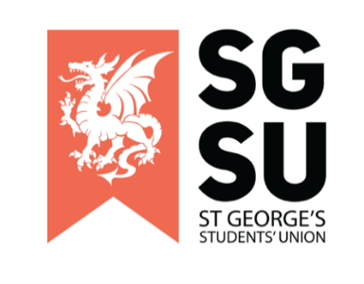
Union Progress Meeting
18th October 2022

6:00pm – 8:00pm, Michael Heron Lecture Theatre

- Apologies

- New society proposals

- None for this month

- General SU update (Elgin)
- Autumn elections announcement
- Society advertising of upcoming events
- Self-Care Week

- Any Other Business (AOB)
- Anya Tidey - Musical painting fee
- Jack Stallard - Pride Soc Open letter

