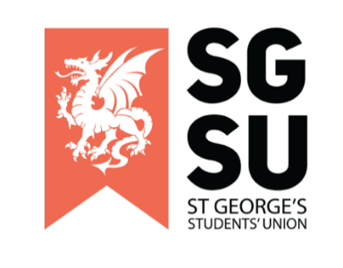
Emergency Union Progress Meeting (UPM)
1st November 2022

6:00pm – 8:00PM, Lecture Theatre F

- Apologies

- To review and consider the minutes from October’s UPM 18/11/2022
- Disclaimer: Any member present at this meeting, is allowed to call for a break due to the sensitive nature of the topics discussed.

- Discussion around Pride Society’s open letter
- Disclaimer: Any member present at this meeting, is allowed to call for a break due to the sensitive nature of the topics discussed.

To Review & Consider
- Introductory Statement – SU President
- Pride Society Open Letter – Presented by Pride Society
- Pride Society Open Letter (Appendix 1)
- Unitu Post Calling for an Emergency UPM (Appendix 2)
- Statement from Students’ Union – Presented by SU

- Any Other Business (AOB)
- Anything raised is to be discussed in next general UPM Meeting (15/11/2022)

Appendix 1: Pride society open letter

Dear Student’s Union Staff

It has been brought to our attention by multiple members of our community that some members of the Student Union do not have pronouns in their emails while others do.

We of course understand the importance of the SU showing allyship and solidarity with the LGBTQ+ community. We would however like to highlight that there are many valid reasons for someone choosing not to publicly disclose their pronouns, including, but not limited to, an individual not feeling safe enough to have their true gender identity regularly announced at the end of every email.

Whilst we will continue to encourage use of pronouns to normalise the recognition of the spectrum of gender identities, we do not wish to make people feel unnecessarily pressured to label themselves if they do not feel comfortable to do so.

We would instead like to address more concerning reports of SU staff members making derogatory comments towards the LGBTQ+ community. It is the responsibility of the SU to be representative of all groups and actively ensure the inclusion, safety, and wellbeing of every student.

Ensuring a safe and welcoming space for all LGBTQ+ students is simply not feasible if not every SU staff member is committed to actively working towards normalisation and full acceptance of every queer identity. This includes holding those that make derogatory or discriminatory comments accountable for their words and actions.

1. We suggest that SU staff include either pronouns or an allyship logo in their email footer. Adding pronouns to email signatures or social and professional profiles can contribute to normalising the importance of not assuming an individual’s gender identity and, using a person’s correct pronouns to foster an inclusive environment that represents all members of society. This can be lifesaving to queer and transgender students by minimising the risk of misgendering both accidentally and deliberately (when done deliberately, this is a hate crime).

We understand that gender non-conforming staff and students may not be comfortable sharing their pronouns and that making this mandatory would be forcing these individuals to publicly expose their gender identity which may not yet be something they are ready to share with the world, and so any form of support for LGBTQ+ students displayed in signatures is acceptable. Examples include sharing pronouns, adding a pride and trans flag to their signature, or writing a statement of support for this community to show their allyship.

2. We request that SU staff take personal and professional responsibility for educating themselves on how to be inclusive and representative of all the diverse communities at SGUL. This would allow us to create a safe and educated community in our university which could support everyone and create a productive learning environment.

3. We ask that SU staff make a commitment to address and confront individuals and groups who have been shown to display discriminatory behaviours, and to support the individuals affected by them. With this we could show the Georges community that homophobia and bigotry will not be tolerated, and make the university safe for all.

We would like to remind the reader that the role of the Student Union is to represent and support the entire student body. St George’s Pride Society are committed to advocating for all students who are members of the LGBTQ+ community and are requesting this support be openly shown by all staff at the students union.

Kind regards,

Pride Society Committee
Jack Stallard, Liv Sutcliffe, Priya Chandrasekaran, Tiggy Robertsoon, Natasha Wollen, Jack Tituana Lliguin

SU Executives
Elgin Edison, Rishi Kumar, Natasha Wollen, Olivia Frost, Anya Tidey, Liv Browne, Jack Stallard, Kaze Ho, Oma Nwibe

Listed below are the societies who support this letter.

Afro-Caribbean Society
Athletics Society
Badminton Society
Biomed Society
Blue Light Champions
Cardiology Society
Climbing Society
Dance Society
Dermatology Society
Diwali Show
Gaming Society
Global Brigades Society
History Society
Indian Society
Krishna Consciousness Society
Ladies Football Club
Ladies Hockey Club
Men’s Cricket Club
Men's Hockey Club
Motorsport Society
Music Society
Musical Society
Netball Club
Neuroscience Society
Paramedic Society
Physio Society
Pride Society
Psychiatry Society
Revue Society
RoundNet Club
Rowing/Boat Club
StreetDoctors
Surgical Society
Swimming Club
Tamil Society
Teddy Bear Hospital Society
Tooting Show
Vegetarian & Vegan Society
Women’s Basketball Club
Women’s Rugby Club

Appendix 2: Unitu post calling for an Emergency UPM

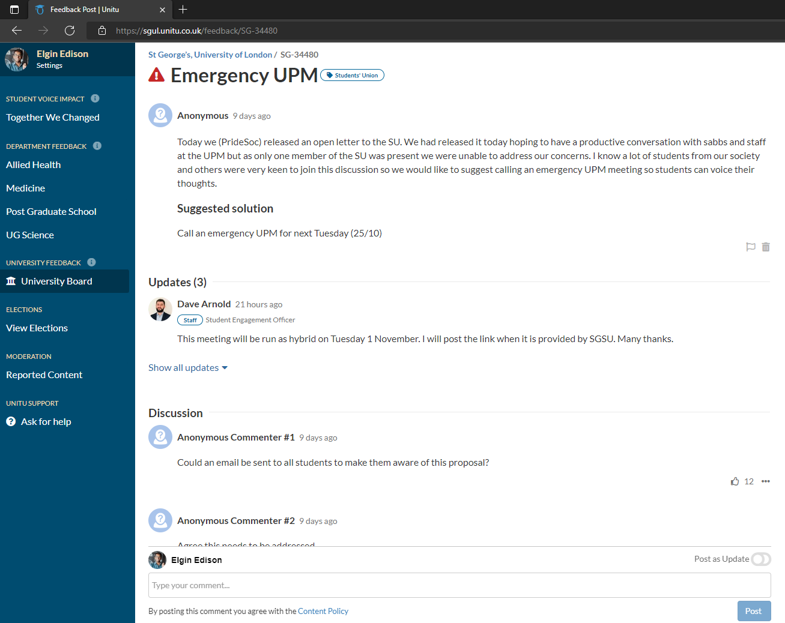
https://sgul.unitu.co.uk/feedback/SG-34480 Accessible via the ‘University Board’ on the ‘In Progress’ category. The post is name is ‘Emergency UPM’

