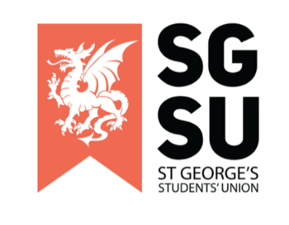

Union Progress Meeting (UPM)
15th November 2022

6:00pm – 8:00PM, Michael Heron Lecture Theatre

- Apologies (Rishi Kumar)

- Review of minutes of last EUPM (Rishi Kumar)

- New Society Proposal
To Review & Consider:
- General Surgery Society (Isaamuddin Alvi)

- EDI presentation (Attai Inueenekpo - University Students Equality Diversity and Inclusion Officer)

- Continuation of discussion around Pride Society’s open letter
To Review & Consider:
- Disclaimer (Ayesha)
- SU Action plan (Ayesha)
- Pride Society Open Letter (Appendix 1)
- Unitu Post Calling for an Emergency UPM (Appendix 2)
- Open letter from the Trustees, Sabbatical Officers, and Staff of the Students’ Union (Appendix 3)

Disclaimer: Any member present at this meeting, is allowed to call for a break due to the sensitive nature of the topics discussed.
After the last session, there were concerns over derailing and discrimination that were raised by members of the student body to our SU Exec. The Union Affairs Zone has created a protocol for this meeting that aims to ensure the safety of all our members, whilst not impacting on their ability to voice their viewpoints nor impacting on the progression of the meeting.
The SU Chair will present these to the UPM, and it can be discussed (5 minutes).

- Any Other Business (AOB)

Appendix 1: Pride society open letter

Dear Student’s Union Staff

It has been brought to our attention by multiple members of our community that some members of the Student Union do not have pronouns in their emails while others do.

We of course understand the importance of the SU showing allyship and solidarity with the LGBTQ+ community. We would however like to highlight that there are many valid reasons for someone choosing not to publicly disclose their pronouns, including, but not limited to, an individual not feeling safe enough to have their true gender identity regularly announced at the end of every email.

Whilst we will continue to encourage use of pronouns to normalise the recognition of the spectrum of gender identities, we do not wish to make people feel unnecessarily pressured to label themselves if they do not feel comfortable to do so.

We would instead like to address more concerning reports of SU staff members making derogatory comments towards the LGBTQ+ community. It is the responsibility of the SU to be representative of all groups and actively ensure the inclusion, safety, and wellbeing of every student.

Ensuring a safe and welcoming space for all LGBTQ+ students is simply not feasible if not every SU staff member is committed to actively working towards normalisation and full acceptance of every queer identity. This includes holding those that make derogatory or discriminatory comments accountable for their words and actions.

1. We suggest that SU staff include either pronouns or an allyship logo in their email footer. Adding pronouns to email signatures or social and professional profiles can contribute to normalising the importance of not assuming an individual’s gender identity and, using a person’s correct pronouns to foster an inclusive environment that represents all members of society. This can be lifesaving to queer and transgender students by minimising the risk of misgendering both accidentally and deliberately (when done deliberately, this is a hate crime).

We understand that gender non-conforming staff and students may not be comfortable sharing their pronouns and that making this mandatory would be forcing these individuals to publicly expose their gender identity which may not yet be something they are ready to share with the world, and so any form of support for LGBTQ+ students displayed in signatures is acceptable. Examples include sharing pronouns, adding a pride and trans flag to their signature, or writing a statement of support for this community to show their allyship.

2. We request that SU staff take personal and professional responsibility for educating themselves on how to be inclusive and representative of all the diverse communities at SGUL. This would allow us to create a safe and educated community in our university which could support everyone and create a productive learning environment.

3. We ask that SU staff make a commitment to address and confront individuals and groups who have been shown to display discriminatory behaviours, and to support the individuals affected by them. With this we could show the Georges community that homophobia and bigotry will not be tolerated and make the university safe for all.

We would like to remind the reader that the role of the Student Union is to represent and support the entire student body. St George’s Pride Society are committed to advocating for all students who are members of the LGBTQ+ community and are requesting this support be openly shown by all staff at the student’s union.

Kind regards,

Pride Society Committee
Jack Stallard, Liv Sutcliffe, Priya Chandrasekaran, Tiggy Robertsoon, Natasha Wollen, Jack Tituana Lliguin

SU Executives
Elgin Edison, Rishi Kumar, Natasha Wollen, Olivia Frost, Anya Tidey, Liv Browne, Jack Stallard, Kaze Ho, Oma Nwibe

Listed below are the societies who support this letter.

Afro-Caribbean Society
Athletics Society
Badminton Society
Biomed Society
Blue Light Champions
Cardiology Society
Climbing Society
Dance Society
Dermatology Society
Diwali Show
Gaming Society
Global Brigades Society
History Society
Indian Society
Krishna Consciousness Society
Ladies Football Club
Ladies Hockey Club
Men’s Cricket Club
Men's Hockey Club
Motorsport Society
Music Society
Musical Society
Netball Club
Neuroscience Society
Paramedic Society
Physio Society
Pride Society
Psychiatry Society
Revue Society
RoundNet Club
Rowing/Boat Club
StreetDoctors
Surgical Society
Swimming Club
Tamil Society
Teddy Bear Hospital Society
Tooting Show
Vegetarian & Vegan Society
Women’s Basketball Club
Women’s Rugby Club

Appendix 2: Unitu post calling for an Emergency UPM

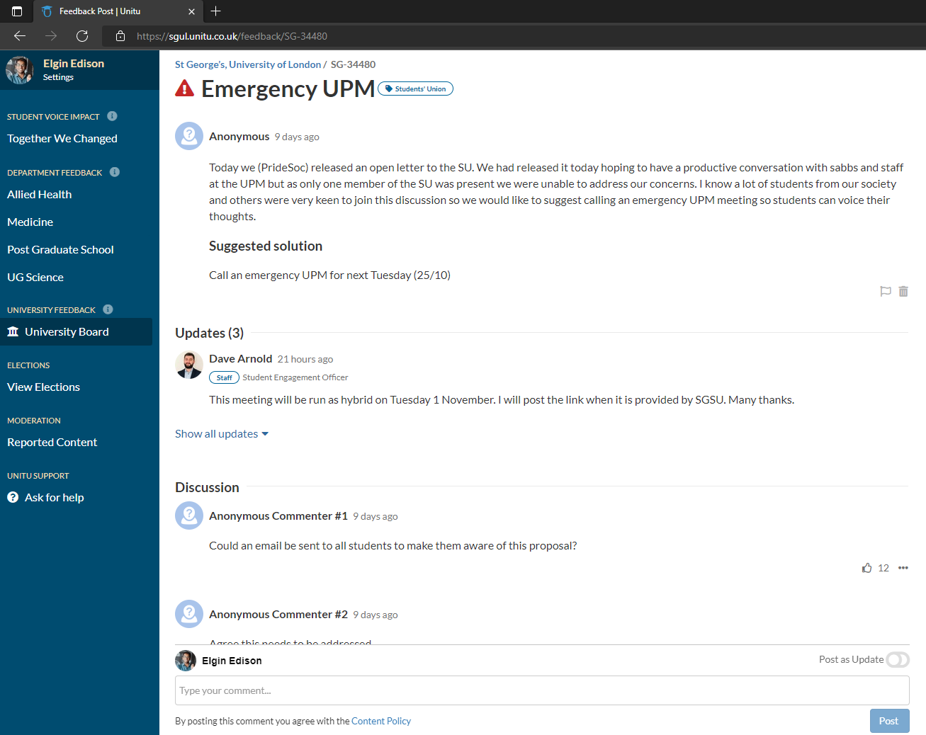
https://sgul.unitu.co.uk/feedback/SG-34480 Accessible via the ‘University Board’ on the ‘In Progress’ category. The post is name is ‘Emergency UPM’

Appendix 3: Open letter from the Trustees, Sabbatical Officers and Staff of the Students’ Union

Dear students,

The St George’s, University of London Pride Society respectfully put forward an open letter to the Students’ Union last week which highlighted concerns around Equality, Diversity, and Inclusion (EDI).
We were very concerned to read this letter. Your Students’ Union aims to create a welcoming and inclusive environment that positively impacts students, clubs, societies, and staff, enhancing the experience for everyone who studies and works at St George’s.

Equality, Diversity, and Inclusion is critical to these efforts. Active listening is key to improvement, and we would like to thank members of the Pride Society and beyond for the time, energy and thought taken to write to us. We hear your concerns and take them extremely seriously.
We would like to address some of the specific concerns raised in the letter, and to set out some of the steps your Students’ Union is taking to improve our EDI practice.

These are ongoing initiatives, and we welcome your feedback.

Pronouns
We agree that allyship is essential to inclusivity. Pronouns are a matter of personal choice and as stated in the letter from Pride, there may be individuals who do not feel comfortable using pronouns in their email signatures, for various reasons.

Education
We hear your request for SU staff to take personal and professional responsibility for educating themselves on how to be inclusive and representative of the diverse communities at SGUL, and will be taking the following additional steps:

- External Equality, Diversity, and Inclusion training for all SU staff and students. Training to be conducted at the beginning of each academic year. The aim of the training will be to help SU staff develop an increased sense of awareness while working with students from different communities and backgrounds. The training will be available to students in committee positions in clubs and societies at St George’s.
- A new cultural committee to foster open communication and engagement There is currently a multi-faith forum group which is there for open communication between the University and students from different faith groups. A new group will be formed with representatives from cultural/community societies invited, to encourage open conversations and collaboration amongst different community groups
- Accessible advice and support We will remind students what options are available for support (including the SU Welfare Assistant, Lon Teija and the University welfare team). We will create a channel where students can raise concerns/feedback safely in a way that gives them the option to take forward to a sabbatical officer or team member.
- Reviewing University & Students’ Union policies The Trustee board are in the process of a governmental review which will include a recommendation to improve resourcing around Democracy and Representation.

Offensive Language
We agree that there is no place in your Union for offensive language towards the LGBTQ+ community or any individual and our Sabbatical Officers and CEO are available to meet representatives of the Pride Society in the coming weeks to discuss matters raised and ensure that there is on-going progress in providing support to the LGBTQ+ community at St.George’s.
How you can get involved
We value the input of the members of Pride Society and all students at St.George’s and there are many ways that you can contribute to Students’ Union life to improve matters, including;
- By standing for election to Officer, Executive committee, and Student Rep positions to ensure your voice is heard,
- By working with the Students’ Union to help promote and organise your events so that the team can both attend your events and be seen to be supporting them,
- By continuing to let us know how we can do better,
We would like to take this opportunity to thank you again for raising these concerns, and to commit to a future of collaborative work with yourselves, creating a welcoming and inclusive environment for all.

Yours faithfully,

Trustees, Students’ Union Sabbatical officers, and staff.

