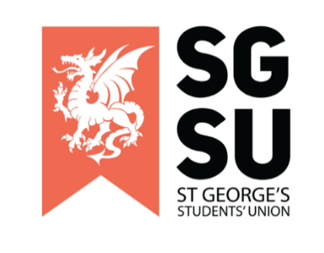
Union Progress Meeting
14th February 2023

6:00PM – 8:00PM, Michael Heron Lecture Theatre

- Apologies

- Review of minutes of the last UPM

- New Society Proposal

To review and consider:
- Anaesthesia Soc (Trevor)
- Sports and Exercise Medicine Soc (Isa)
- Persian Soc (Hussain)

- Highlighting Society Events

To review and consider:
- Advertising society events in the coming months

- SU update

To review and consider:
- An oral update from the VP of Education & Welfare (Elgin)
- Raising And Giving (RAG) Week

- Society Update

To review and consider:
- General rules for putting posters up around the uni

- Any Other Business (AOB)

- Apologies

Formal apologies provided by Henry Gray Anatomy Society

- Review of minutes of the last UPM

No corrections/clarifications of the last UPM (Nov)
Vote to approve the minutes, 18 yes, 0 no, 0 abstaining

- New Society Proposal

Anaesthesia Society – Presented by Trevor Lui
Questions raised around subs £5, money from subs goes to fund workshops. Activities involve the setting up of workshops around the subject of anaesthesia. The society will help set up shadowing opportunities on the weekdays under an appropriate code of conduct.
Vote to approve the Anaesthesia Society proposed by Mihran, seconded by Ariya. 33 yes, 0 no, 0 abstaining. Society passed!

Sports and Exercise Medicine Society – Presented by Isa Waheed
A former society, this new committee wished to bring it back.
A question was raised around potential collaboration with sports societies. The answer was to instead focus on working with other Sports and Exercise Medicine societies across different universities.
A question was raised on potential workshops and people to invite. Isa mentions that they are currently shadowing football doctors at AFC Wimbledon and have recently been appointed South England representative of the Undergraduate Sports and Exercise Medicine society, a nationwide organisation. Isa mentions making good connections with sports doctors and hopes to invite some of them down.
Vote to approve the Sports and Exercise Medicine Society proposed by Mihran, seconded by KB. 17 yes, 0 no, 0 abstaining. Society passed!

Persian Society – Presented by Hussain Mosallaey

A question was raised around the setting up of a new charity. It was clarified to be a typo.
Vote to approve the Persian Society proposed by KB, seconded by Trevor. 7 yes, 0 no, 0 abstaining. Society passed!

- Highlighting Society Events

None mentioned in this meeting

- SU Update – Presented by Elgin Edison

An oral update from the VP of Education & Welfare

A brief reflection of being 6 months into the role, the experience gained and mention of key learning points to improve on. Working more so with fellow students and staff.

Raising and Giving (RAG) Week

A brief mention of the following events:
- Valentines circles (15/02/2023)
- Quiz night (16/02/2023)
- SU Friday (17/02/2023)

- Society Update

General rules for putting posters up around the university
Seven posters can be stamped and approved. Please do not place them in elevators and the toilets.
- Any Other Business (AOB)

No other points mentioned

Meeting closed

