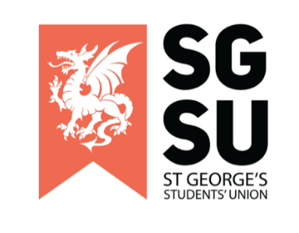
Union Progress Meeting
14th February 2023

6:00PM – 8:00PM, Michael Heron Lecture Theatre

- Apologies

- Review of minutes of the last UPM

- New Society Proposal

To review and consider:
- Anaesthesia Soc (Trevor)
- Sports and Exercise Medicine Soc (Isa)
- Persian Soc (Hussain)

- Highlighting Society Events

To review and consider:
- Advertising society events in the coming months

- SU update

To review and consider:
- An oral update from the VP of Education & Welfare (Elgin)
- Raising And Giving (RAG) Week

- Society Update

To review and consider:
- General rules for putting posters up around the uni

- Any Other Business (AOB)

