Union Progress Meeting
23rd August 2022

6:00pm – 10:00pm, Michael Heron Lecture Theatre

- Apologies for Absence (Rishi)

Apologies from the following societies and individuals were announced:

Apologies received from: Obstetrician and Gynaecology soc, Ladies Football, Telugu Soc, Men’s Cricket, Roundnet Soc, Paksoc, Palestinian soc, Emergency medical soc, Mallu Soc, Rugby, Dermatology soc, Olivia Browne, Jack Stallard

- New society proposals

Turkish Society presented by Sofia Sohinz. Points raised include:

- Will run meet & greets
- Chai tea sessions would be run
- Football and movie nights
- Celebrate various Turkish festivals
- Taste of Turkey events where members make and bring in food
- Bowling nights. Have at least 2 events a month. Subs of £2.
- Helps bring the community together.

Consideration:

- President of Arab soc asked whether there would be opportunity to create events in collaboration, Sofia agreed.
- Questions were raised as to why Turkish society has not existed before; Sofia does not know why.
- Becky Kemp asks how many members are interested. Sofia responded that all required officer roles have been filled and that there were enough nominations to proceed.
- It has been raised that a wellbeing officer will need to be elected.

Voting:

- Representative was asked to leave the Michael Heron.
- No questions asked and no concerns raised.
- Olivia Frost puts forward the motion, Natasha Wollen seconded the motion. 38 votes for yes. 0 votes no. 4 votes abstain.

- Strategic Update

SU strategy for the year (Ayesha):

- Increasing conversation between staff and students in both formal and informal settings.
- Continuing following up on the current action points around welfare.
- Being more representative of our student body in the events we run. Liaising with societies to help run and fund events.
- Increasing accessibility of information about societies.
- Being more present so the students are aware of our existence and importance.

- Student activities update

Update on student activities (Ogor):

- Any societies would like a Freshers’ stalls please fill in the form emailed.
- Minibus drivers needed for the move in weekend. If you have had a driver’s license for over 2 years, no point on your license and over 21 please fill in the form emailed.
- We require help for the move in weekend on the 24th – 25th September at halls. If any members of your societies are available, please fill in the form emailed.
- Can all the handover forms be filled in by previous presidents. These forms have been emailed.
- Budgets have been cut by 5%, subs may need to be raised.

- Fresher’s Planning update

An update on Fresher’s Planning. (Ayesha)

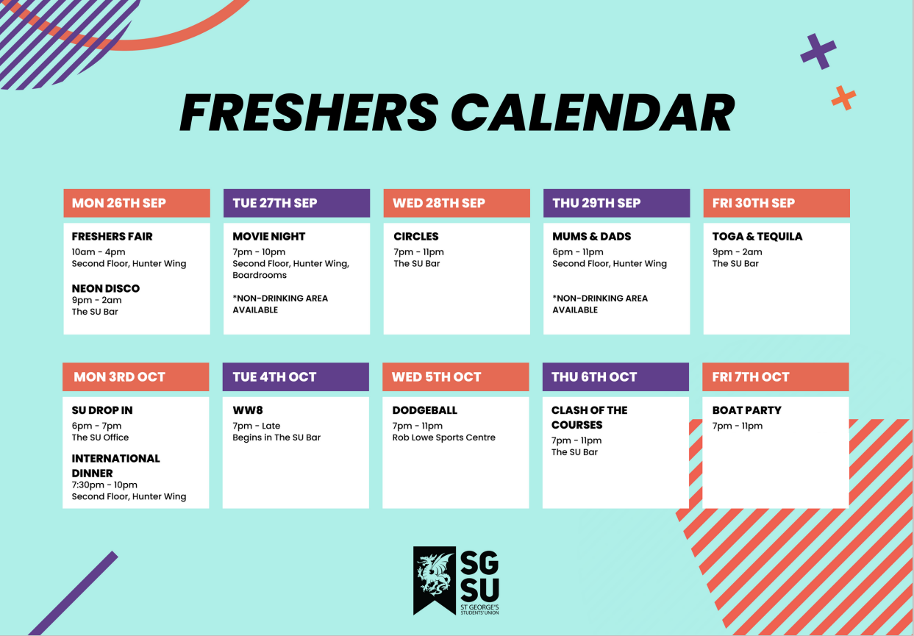

- Communications (Ayesha)

Information on social media and communications manager, Alex. (Ayesha)

- Alex Benjamin (abenjami@sgul.ac.uk)
- Alex can give you tips and tricks on how to communicate with members of our community
- Tag us in Instagram stories for us to share more information about your events
- Approach Alex for events

- Exec of the month (Ayesha)

Presentation of award to Exec of the Month

Omre Urmani, Tech Officer, is exec of the month.

- Any Other Business

- Clarification of trials process - coaches can booked. This must be done on a society basis.
- Kiran asked about a missing speaker in the AHR. – students have been bringing in their own speaker and is asking whether the old speaker will be replaced. Ayesha Patel will let Kiran Know about the situation with the speaker during the first week of September.
- Welfare being officer training. Elgin Edison announces the date and further details of Wellbeing officer training. Members from the AFC who aren’t elected wellbeing officers would like to attend this training. Elgin Edison advised that the more members attending the merrier. Elgin Edison will send clarification of the date, whether the meeting will be hybrid later.
- Will Freshers events be open to all students? Around 200 tickets per disco will be available via ticket source. All students are welcome to join us at events if they have a ticket.
- Ayesha brings a message from Michelle Campbell (mcampbel@sgul.ac.uk):
New webpages
- Club or Society logo (high resolution JPEG image) 1400px (w) X 480px(h) or a photograph (high resolution JPEG image 1400px(w) X 480px (h) This photograph will feature at the top of the page and on the club and society homepage (could be a team photograph, a photograph from an event or one that accurately represents your club/society)
- Links to social media pages
- General information about the club/society (max 300 words)
- Details about training sessions/regular meetings (day, location, time)
- Details of membership costs
- Links to purchase club kit

Existing webpages
- Updated text or logo
- Society photographs to add to the gallery section
- Links to purchase club kit

Events listing
I can add events to the events calendar. I will need the following:
- Full details of the event (date, time, location etc…)
- Ticket information, I can create a link to feature on the listing
- An image to feature on the page - (high resolution JPEG image) 1400px (w) X 480px(h)

Club/society SU email account
- The names and email addresses of up to 5 committee members who require access
If the club/society does not have an SU email account, I can create one. I’ll need the info as above.

Digital screens
To feature club/society events and achievements
I will need a high-res JPEG 1080px (w) x 1920px (h)

All events and club and society webpages will automatically feature on the app. How to get the SU app: Download Student link on the App Store or Google Play. Select St George’s Students’ Union and follow the set-up instructions.

- External Visitors Rules – SU needs to be aware when External people are invited onsite for society-based reasons. Please notify us when booking the room. An email of a full list of external members attending events needs to be sent to the SU, Mel Masters and Elizabeth Gilby at least a week before the event and on the day of the event register any external students and then the list must be taken down to Security.
- Holly Parker asks if external forms should be filled in for those visiting the Rob Lowe. Ayesha says yes.
- Someone asks if an all-student email will be sent that clarifies all the AoBs. Yes.

UPM/20/09/2022-23/Paper A

Post Grad Reps Proposal

To: Exec Zone Meeting
Date: 6th September 2022
Presented by: Ayesha Patel
Written by: Ayesha Patel

Intro:

Within our SU the post grads are not as engaged as we would like them to be, this is due to many reasons.

We have been in contact with both the Post Grad Research team and some Post Grad research students. We have been able to identify how as the SU, we could be more inclusive to a large group of students within our community. There are multiple ways in which we can do this, and we are already actioning this.

A keyway that we propose to help deal with this gap that we would like to begin is introducing Post Grad reps. This would help the SU represent Post Grads by being able to feed information to these reps and have information fed out to us.

Therefore, we propose a change to the bylaws by adding the roles below to the exec.

Post Grad Research 2 Exec Positions - Up to 2 people may run as a team.

General roles and responsibilities of Post Grad Research exec shall include:

(a) Being the first point of call for issues pertaining to Post Grad Research Students
(b) Being a Post Grad as the group of Students they hope to represent come the beginning of their term in office.
- (c) Attending and provide formal handover at the first Senate meeting following elections.
- (d) Meeting with the head of post grad research and the post grad research administrator as soon as possible following taking office to build a functional working relationship.
- (d) Attending the Year Representative training at the start of the Academic Year that is organised by the Vice President for Education and Welfare

Year Representatives shall have the following Union related roles and responsibilities (unless excluded below):

- (a) Shall represent the views of their year at Senate and any other Union meetings that it is relevant for them to attend.
- (b) Shall report on their activities to each Senate meeting, either through a verbal report at the meeting or through a written report submitted in advance to the Representation Officers.
- (c) Shall produce and submit a full report on their term in office to the Representation Officers, prior to the AGM.
- (d) Shall disseminate appropriate information following Senate and relevant course committee meetings
- (e) Are responsible for promotion of events being organised by the Union where appropriate and in line with the email policy of the University.
- (f) Must keep the Senior Officers informed about all issues pertaining to their respective course.
- (g) Promote, organise group photos.

Post Grad Taught 2 Exec Positions - Up to 2 people may run as a team.

General roles and responsibilities of Post Grad Research exec shall include:

- (a) Being the first point of call for issues pertaining to Post Grad Research Students
- (b) Being a Post Grad as the group of Students they hope to represent come the beginning of their term in office.
- (c) Attending and provide formal handover at the first Senate meeting following elections. (d) Meeting with the head of post grad research and the post grad research administrator as soon as possible following taking office to build a functional working relationship.
- (d) Attending the Year Representative training at the start of the Academic Year that is organised by the Vice President for Education and Welfare

Year Representatives shall have the following Union related roles and responsibilities (unless excluded below):

- (a) Shall represent the views of their year at Senate and any other Union meetings that it is relevant for them to attend.
- (b) Shall report on their activities to each Senate meeting, either through a verbal report at the meeting or through a written report submitted in advance to the Representation Officers.
- (c) Shall produce and submit a full report on their term in office to the Representation Officers, prior to the AGM.
- (d) Shall disseminate appropriate information following Senate and relevant course committee meetings
- (e) Are responsible for promotion of events being organised by the Union where appropriate and in line with the email policy of the University.
- (f) Must keep the Senior Officers informed about all issues pertaining to their respective course.
- (g) Promote, organise group photos.

