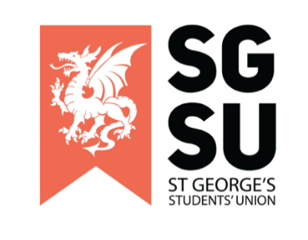
Union Progress Meeting
23rd August 2022

6:00pm – 10:00pm, Michael Heron Lecture Theatre

- Apologies for Absence (Rishi)

Apologies from the following societies and individuals were announced:

Apologies received from: Obstetrician and Gynaecology soc, Ladies Football, Telugu Soc, Men’s Cricket, Roundnet Soc, Paksoc, Palestinian soc, Emergency medical soc, Mallu Soc, Rugby, Dermatology soc, Olivia Browne, Jack Stallard

- New society proposals

Turkish Society

- Strategic Update

SU strategy for the year (Ayesha)

- Student activities update

Update on student activities (Ogor)

- Fresher’s Planning update

An update on Fresher’s Planning. (Ayesha)

- Communications (Ayesha)

Information on social media and communications manager, Alex. (Ayesha)

- Exec of the month (Ayesha)

Presentation of award to Exec of the Month

- Any Other Business (AOB)

